PHP Project

# Project Title: Bank Simulator

# Date: 6th July

# Project By:

# Puneet Jain

# Saurav Maheshwary

# Vikash Chand Kumar

Acknowledgement

We are grateful to our mentor, Mr. Sajib Paul for the guidance, inspiration and suggestions that helped us in the preparation of this project.

We would not have been able to learn the nitty-gritties of PHP without him.

Puneet Jain

Saurav Maheshwary

Vikash Chand Kumar

Table of Contents

1. Synopsis
   * 1. Introduction
     2. Functional Requirements
     3. Operational Concepts and Scenarios
     4. Interface Requirements
     5. Non Functional/Specific Requirements
     6. Assumptions/Dependencies/Limitations
     7. Acceptance Criteria
     8. Allocation of System Requirements
     9. Others
     10. Acronyms and Glossary
2. Entity Relationship Diagrams
3. Class Diagrams
4. Screenshots
5. Conclusion
6. Bibliography

Synopsis

# 1. INTRODUCTION

**Project Title:**

Bank Simulator

**Purpose of the project:**

This project facilitates the manager and teller to maintain user account details and transactional details.

**Scope and Overview:**

This is web based application which allows Admin to create bank account, add user, display daily transactions and maintain transaction records.

**Modules/Sub Modules:**

**1. Manager Module**

* + - Login
    - Create Account
    - Add User
    - Deposit Amount
    - Withdraw Amount
    - Transfer Amount
    - Transaction Details

**2. Teller Module**

* + - Login
    - Deposit Amount
    - Withdraw Amount
    - Transfer Amount
    - Transaction Details
    - Teller Transaction Details

# 2. Functional Requirements

**Login:**

Allows the manager (admin)/teller to login into the Bank Simulator application.

**Create Account:**

This application allows the manager to create a new account.

**Add User:** To create a username, password, re-enter password, full name and roles (teller, customer)

**Deposit Amount:**

Allows manager/teller to deposit an amount.

**Withdraw Amount:**

Allows the manager/teller to withdraw a particular amount.

**Transfer Amount:**

Allows the manager to transfer particular amount.

**Transactional details:**

Displays all the transactions with following details:

* Transaction ID
* Transaction date
* Transaction details
* Debit/Credit
* Balance

**Teller Transactions Details**:

It allows manager to view Teller Transaction Details such as

* Account number
* Transaction type
* Amount

**Daily Transaction Details:**

Allows manager to view daily transactions. This includes

* Username
* Account number
* Transaction type
* Amount

## *2.1* *Operational Concepts and Scenarios*

* The system provides facility to enter information into the database.
* The information will be stored in the user accounts if all the necessary details are correct.
* The administrator provides the privilege to the teller for updating the data. The system allows the manager to login.

## *2.2 Interface Requirements*

* The Manager and Teller will communicate with the system through GUI. The common login page will provide directions for the respective users.
* To achieve the expected functionality, the system does not need any external interfaces. The system is expected to perform well under any normal circumstances.

# 3. Nonfunctional/Specific Requirements

**Server Software:**

* PHP 5.3.5 supported Apache 2.2.17
* MySQL 5.5.8
* Windows XP

**Server Hardware:**

* Pentium IV
* RAM 512 MB

**Client Software:**

* Any browser(Firefox, Internet Explorer, Opera, etc)

**Client Hardware:**

* Pentium IV
* RAM 512 MB

# 4. Assumptions/Dependencies/Limitations

* Assume Manager as database administrator.
* Teller Module depends on Manager Module.
* Teller has the limitations to create user account and add user

# 5. Acceptance Criteria

* User name field should not be blank
* Account number should not be less than six numbers
* Password should be greater than eight characters
* Minimum account balance should be greater than Rs.500

E-R Diagram

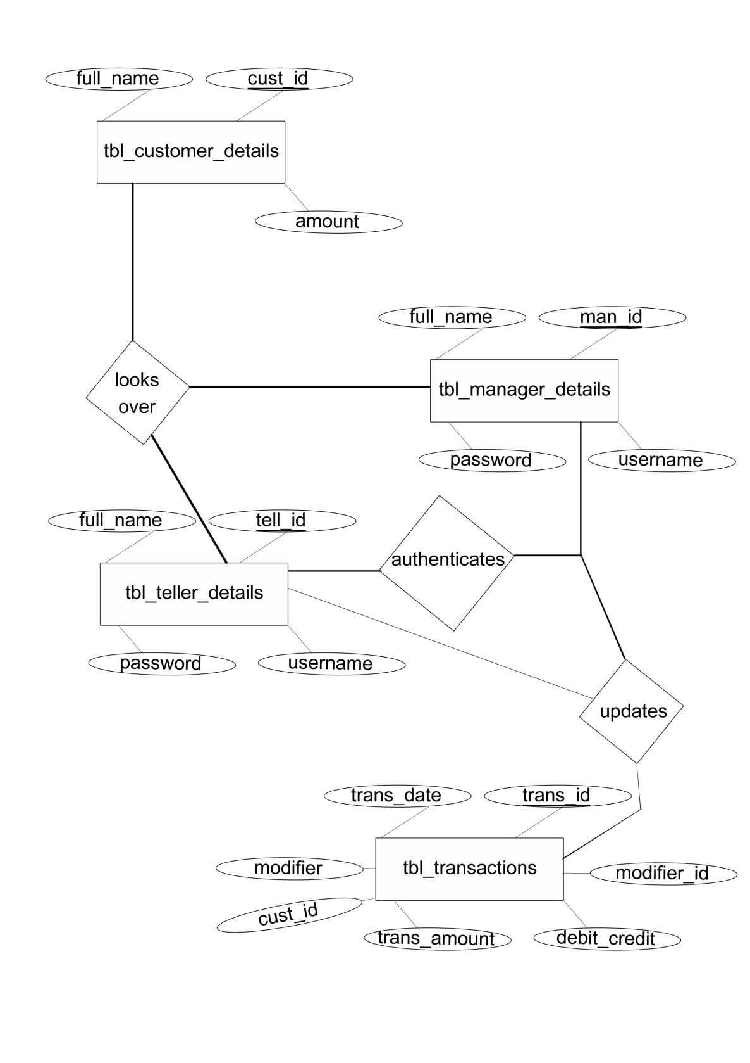

Screenshots

index.php

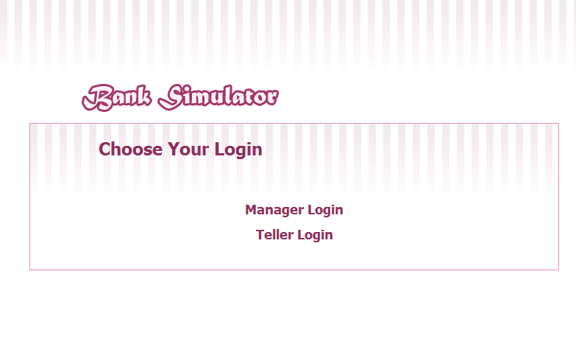

manager_login.php

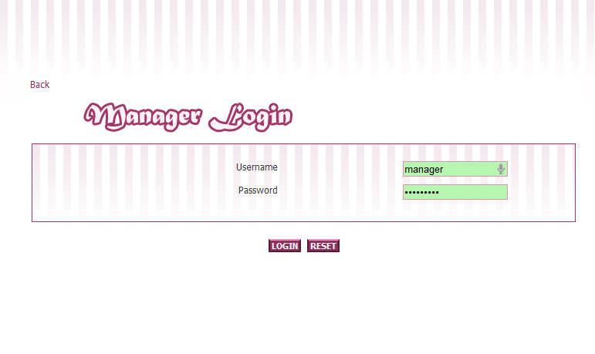

manager_options.php

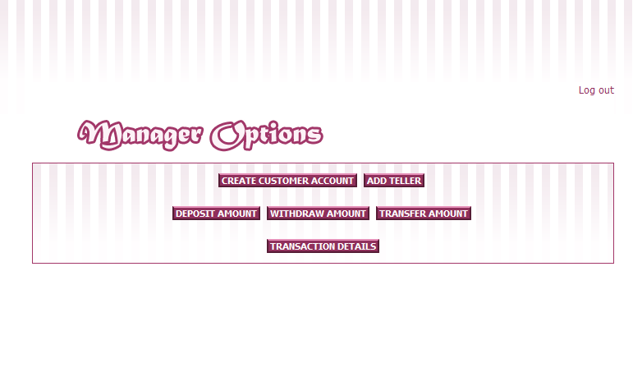

create_customer_account.php

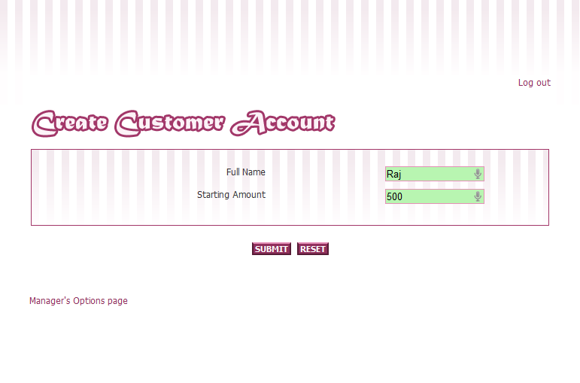

transfer_amount.php

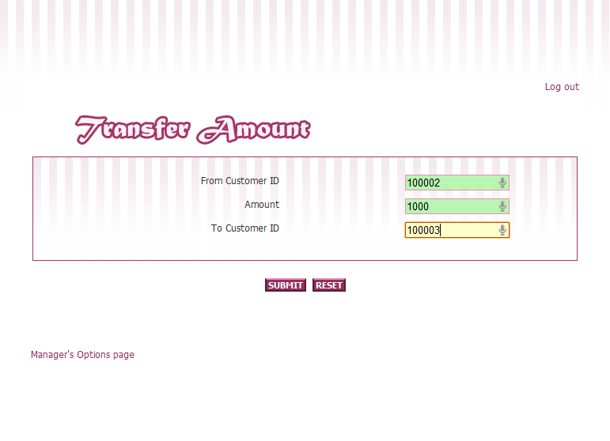

daily_transaction_details.php

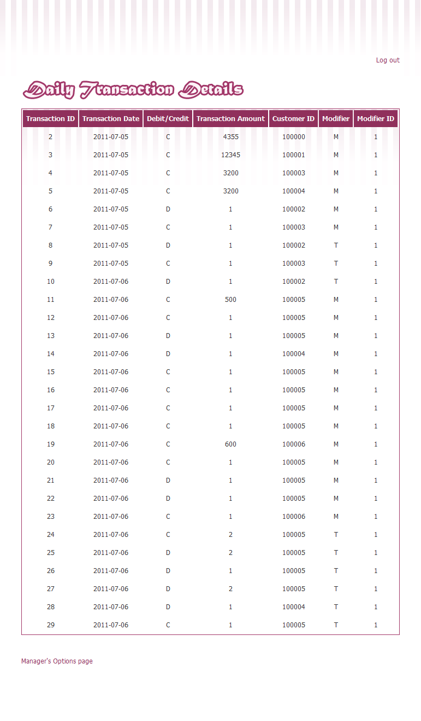

Conclusion

The goal of this project has been to create a stable and useful Bank Simulator Web Application using PHP tools and MySQL.

The system has been extensively tested to make it almost all bugs free and operates with high levels of efficiency to solve the problem it is supposed to.

Bibliography

Websites:

www.php.net

PHP Essential Training-www.lynda.com

PHP Beyond the Basics-www.lynda.com

Books:

PHP Manual, by Ardent Computech PVT. LTD.

Certificate of Originality

## **To Whom It May Concern**

This is to certify that the project report namely Bank Simulator, submitted to **Ardent Computech PVT. LTD.** is an original work carried out by **Puneet Jain, Saurav Maheshwary** and **Vikash Chand Kumar** all students of **Heritage Institute of Technology, Kolkata** under the guidance of **Mr.Sajib Paul**.

**Sajib Paul Ardent Computech PVT. LTD. Official Seal and Signature**